A PROJECT REPORT

on

“CHATBOT USING PYTORCH”

Submitted to

KIIT Deemed to be University

In Partial Fulfillment of the Requirement for the Award of

BACHELOR’S DEGREE IN

COMPUTER SCIENCE AND SYSTEMS ENGINEERING

BY

SUDIPA MANDAL
RITWIKA DE

2028036
2028174

UNDER THE GUIDANCE OF

MS. SANTWANA SAGNIKA



SCHOOL OF COMPUTER ENGINEERING

KALINGA INSTITUTE OF INDUSTRIAL TECHNOLOGY

BHUBANESWAR, ODISHA - 751024

May 2023

KIIT Deemed to be University

School of Computer Engineering
Bhubaneswar, ODISHA 751024

CERTIFICATE

This is certify that the project entitled

“CHATBOT USING PYTORCH“

submitted by

SUDIPA MANDAL
RITWIKA DE

2028036

2028174

is a record of bonafide work carried out by them, in the partial fulfillment of the requirement for the award of Degree of Bachelor of Engineering (Computer Sci-ence & Systems Engineering) at KIIT Deemed to be university, Bhubaneswar. This work is done during year 2022-2023, under our guidance.

Date: / /

Ms. Santwana Sagnika
Project Guide

Acknowledgements

We are profoundly grateful to Ms. Santwana Sagnika of School of Computer Engineering for her expert guidance and continuous encouragement throughout to see that this project rights its target since its commencement to its completion. .....................

SUDIPA MANDAL

RITWIKA DE

ABSTRACT

This project aims at developing a customer service chatbot for a restaurant using Pytorch framework which provides a user-friendly interface for the customers. The chatbot is trained to recognize and respond to a wide range of customer inqueries including menu items, payment details and delivery inqueries. By using natural language processing (NLP) and deep learning techniques, the chatbot is able to provide precise response to each customer inquery, thus improving customer satisfaction.

Keywords: chatbot, Pytorch, customer service, restaurant, natural language processing , deep learning

Contents
1 | Introduction |  |  |  | 1
2 | Basic Concepts |  |  |  | 2
 | 2.1 | Natural Language Processing |  |  | 2
 |  | 2.1.1 | Bag of Words |  | 2
 |  | 2.1.2 | Tokenization |  | 2
 |  | 2.1.3 | Stemming |  | 2
 |  | 2.1.4 | Tagging |  | 2
 | 2.2 | Deep Learning techniques |  |  | 3
 | 2.3 | Pytorch framework |  |  | 3
 | 2.4 | Tkinter |  |  | 3
3 | Problem Statement |  |  |  | 4
 | 3.1 | Project Planning |  |  | 4
 | 3.2 | Project Analysis |  |  | 5
 |  | 3.2.1 | Project Perspective |  | 5
 |  | 3.2.2 | Project Functions |  | 5
 |  | 3.2.3 | Functional Requirements |  | 5
 |  | 3.2.4 | Non-Functional Requirements |  | 6
 | 3.3 | System Design |  |  | 6
 |  | 3.3.1 | Design Constraints |  | 6
 |  |  | 3.3.1.1 | User Interface | 6
 |  |  | 3.3.1.2 | Backend | 6
 |  |  | 3.3.1.3 | Natural Language Processing (NLP) | 6
 |  | 3.3.2 | System Architecture |  | 6
4 | Implementation |  |  |  | 7
 | 4.1 | Methodology |  |  | 7
 | 4.2 | Testing |  |  | 8
 | 4.3 | Result Analysis |  |  | 11
 | 4.4 | Quality Assurance |  |  | 13
5 | Standard Adopted |  |  |  | 14
 | 5.1 | Design Standards |  |  | 14
 | 5.2 | Coding Standards |  |  | 15
 | 5.3 | Testing Standards |  |  | 15
6 | Conclusion and Future Scope |  |  |  | 17
 | 6.1 | Conclusion |  |  | 17
 | 6.2 | Future Scope |  |  | 17
References |  |  |  |  | 18
Individual Contribution |  |  |  |  | 19
Plagiarism Report |  |  |  |  | 21

List of Figures

1. An example of a chatbot 1
2. Feed Forward Neural Network 3
3. System Architecture 6
4. Methodology 4
5. Starting Window 11
6. A Sample Conversation 11

Chapter 1

Introduction

For e-commerce websites and business owners, addressing customers’ grievances is an important part for the smooth functioning of their business. Businesses may find it challenging to provide satisfactory customer service, particularly during peak hours or outside regular business hours. Managing customer inquiries manually can be time-consuming and inefficient, resulting in slower response times and increased costs. They may miss out on opportunities to engage with customers and provide personalized recommendations, offers, and information. They may also need to hire additional staff to manage customer inquiries, which can increase costs and decrease profitability. Handling high volumes of inquiries may be a struggle, which can limit their ability to scale and grow. They may miss out on valuable customer data, such as preferences, behaviors, and pain points, which can be used to enhance customer service and marketing strategies.
This is where chatbots come into the picture. A chatbot is a software program or computer application that can simulate human conversation or "chatting" through text or voice interactions. It is designed to engage in conversation with users and assist them in completing specific tasks. Chatbots use natural language processing (NLP) and machine learning algorithms to understand and interpret user requests. They then provide responses that are relevant and helpful. Chatbots are widely used in a variety of applications, including customer service, sales, and marketing. They can help businesses automate processes, provide personalized experiences to customers, and reduce costs associated with human customer service representatives.

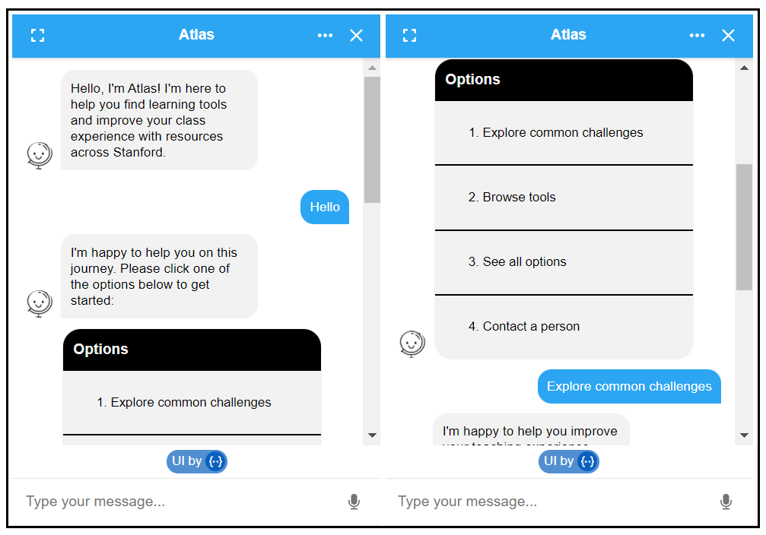

Figure 1 : An example of a chatbot
:

Chapter 2

Basic Concepts

This section contains the basic concepts about the related tools and techniques used in this project.

2.1 Natural Language Processing
It is a subfield of artificial intelligence which deals with interaction between humans and computers using natural language. It helps the chatbot to interpret customer inqueries and respond accordingly. The NLP concepts used in this project are -

2.1.1 Bag of Words
A bag of words is a simple representation of a text document as a collection (or "bag") of its unique words. It disregards grammar and word order but takes a piece of text and breaks it down into individual words, whose frequencies are counted and represented as a vector. This concept is useful for feature extraction.

2.1.2 Tokenization
It is the process in which the raw text is broken down into smaller parts called "tokens" which are separated by spaces or special characters. Tokenization is a part of preprocessing techniques used in NLP process

2.1.3 Stemming
Stemming involves detecting the base form of a word and reducing it to it's root form known as "lemmas". It involves removal of prefixes and suffixes. For example the stem word for the word reading is read.

2.1.4 Tagging
It is the act of assigning a label to the parts of speech (POS) based on its context. In this project we have used tags to label different types of queries like greetings, goodbye, items etc.

2.2 Deep Learning techniques
In our project we have used a deep learning technique called "feed forward neural network". A feed forward network has 3 layers- an input layer, hidden layers and an output layer. In this type of network data flows in only one direction i.e. forward. Here the input layer takes bag of words as input. Our model has two hidden layers. Each hidden layer performs some computational processes to produce the output layer. The output layer has the final result of the neural network consisting of the relevant classification label.

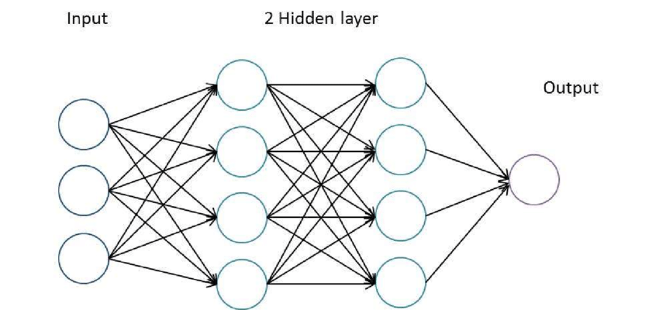

Fig 2 : Feed Forward Neural Network

2.3 Pytorch framework
Pytorch is a powerful machine learning framework which is used in training deep learning models. In our project we have used torch.nn module which provides all the building blocks to prepare a neural network model like parameters, containers, layers and functions.

2.4 Tkinter
Tkinter is a python based GUI package used to create simple applications. In this project the chatbot model is integrated with the Tkinter user interface for easy customer interaction. Widgets like chat window, scrollbar, enter button, clear chat button have also been added in our application using Tkinter.

Chapter 3

Problem Statement

Businesses find it challenging to provide satisfactory customer service, particularly during peak hours or outside regular business hours. This may result in frustrated customers who seek better service from competitors. Managing customer inquiries manually can be time-consuming and inefficient, resulting in slower response times and increased costs. They may also need to hire additional staff to manage customer inquiries, which can increase costs and decrease profitability. Threrefore, an automated way of collecting and resolving customer queries is needed.

3.1 Project Planning

- Define the purpose and scope: The first step is to define the purpose of the chatbot and its scope. This includes identifying the target audience, the problems the chatbot will solve, and the goals it aims to achieve.

- Choose a platform: Once the purpose and scope are defined, the next step is to choose a platform for developing the chatbot. Some popular platforms for building chatbots include Dialogflow, Botpress, and IBM Watson Assistant.

- Design the conversation flow: Designing the conversation flow involves mapping out the conversation between the chatbot and the user. This includes identifying the user's intents, designing the responses, and creating a flowchart that outlines the chatbot's logic.

- Develop the chatbot: In this step, the chatbot is built using the chosen platform. This involves coding the chatbot's responses and integrating it with the desired messaging platform, such as Facebook Messenger or Slack.

- Test the chatbot: The chatbot needs to be tested to ensure that it functions correctly and provides useful responses. This involves testing for errors and bugs and making necessary adjustments.

- Deploy the chatbot: The final step is to deploy the chatbot to the desired platform. This involves making it available to users and ensuring that it is accessible and easy to use.

- Monitor and maintain: This includes tracking user interactions, collecting feedback, and making updates as necessary to ensure that the chatbot continues to meet its goals and provide value to users.

3.2 Project Analysis

3.2.1 Project Perspective:

- The purpose of this project is to design a chatbot using PyTorch, which can be used for customer services and address their issues.
- The chatbot will be designed to provide a user-friendly interface for customers to interact with the chatbot.
- The system will be designed to recognize and respond to customer inquiries, complaints, and requests.

3.2.2 Project Functions:

- User-friendly interface: The chatbot will have a simple and intuitive interface that allows customers to easily interact with the chatbot.
- Intelligent responses: The chatbot will be trained on a large dataset of customer interactions to provide accurate and relevant responses to customer inquiries.

3.2.3 Functional Requirements:

R1 : Recognition of Customer enquiries
Input: Customer inputs their problem statement and presses Enter
Output: The chats appear in the Tkinter window and the model processes the queries

R2 : Response Generation
Input: Queries inputed by the customer
Output: The chatbot will generate appropriate responses based on
the customer inquiry or complaint.

R3: Clear Chat button
Input: The customer presses the Clear Chat button
Output: The chats inside the Tkinter window disappears

R4: Scroll button
. Input: The customer drags the scroll button up and down
. Output: Allows customers to easily navigate through the chats.

R5: Training Data Management
Input: Possible inputs and responses are pooled in the intents.json file
Output: The chatbot is trained based on the dataset, and the system will e be designed to use this data.

3.2.4 Non-functional Requirements:

N1: Performance Requirements
- The chatbot is designed to respond quickly and accurately to customer inquiries.
N2: Externel Interface Requirements
- The user interface of the bot should be eye-catching.
- The user interface should be user friendly

3.3 System Design

3.3.1 Design Constraints
3.3.1.1 User Interface
- The chatbot will have a user interface where customers can interact with the bot through a chat interface.
- The UI will be built using a framework called Tkinter which will allow users to enter text inputs and receive text responses from the bot.
3.3.1.2 Backend
- The chatbot's backend will be built using PyTorch, a popular deep learning framework.
- The backend will be responsible for processing user inputs and generating responses.
- The model will be trained on a large corpus of customer service interactions, allowing it to generate accurate and relevant responses.
3.3.1.3 Natural Language Processing(NLP)
- The chatbot will use NLP techniques to understand user inputs and generate appropriate responses.
- NLP techniques include Stemming(reducing a word to it's root form), Tokenization(splitting the raw sentences into relevant tokens), Bag of Words(a method of feature extraction) and Tagging(labelling words in the raw text).

3.3.2 System Architecture

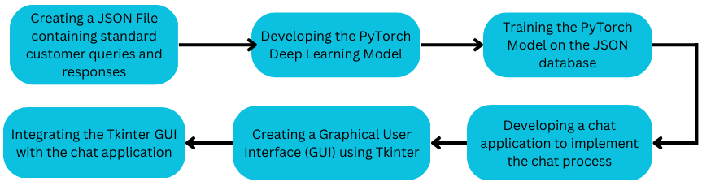
Fig 3 : Block Diagram

Chapter 4

Implementation

4.1 Methodology
- Loop through each sentence in our intents JSON file, tokenize the text and apply stemming.
- Exclude punctuation characters and remove duplicate words.
- Convert the above text into a bag of words.
- Create a feed forward neural network function with 3 layers, 1 input layer and 2 hidden layers.
- Pass the training data as inputs into the neural network.
- Apply softmax function to the output layer to calculate the probabilities of the outputs and choose the output with the highest probability.
- Save the model.
- Create a chat application to simulate the’ chatting’ process between the user and the bot.
- Import and integrate the model with the chat application.
- Integrate the chat application with the Tkinter GUI.

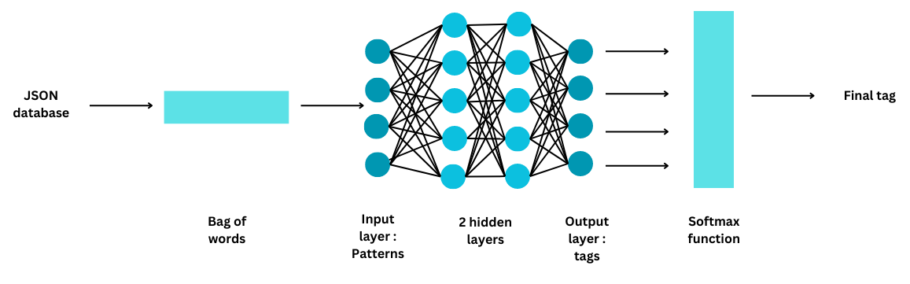
Fig 4 : Methodology

4.2 Testing

The following test cases for the chatbot were verified -

Test Case 1 - Fails to recognize user input
- Test Condition - The user asks a question unrelated to the tags. For example - " What is my favorite color?"
- System Behaviour - "I do not understand..."
- Expected Result - "I do not understand..."

Test Case 2 - User greets the bot
- Test Condition - The user inputs any one of the following - "Hi", "Hey", "How are you", "Is anyone there?", "Hello", "Good day". Alternatively, the user may input a greeting similar in nature to these options like "Hey there"
- System Behaviour - "Hey :-)"
- Expected Result - Any one of the following - "Hey :-)", "Hello, thanks for visiting", "Hi there, what can I do for you?", "Hi there, how can I help?", "Hello! Please be free to ask any questions. I love them!", "Hello! how can I help you today?", "Hey! Thank you for chatting with me. I’m here to help you with anything you need."

Test Case 3 - User thanks the bot
- Test Condition - The user inputs any one of the following -
"Thanks", "Thank you", "That's helpful", "Thank's a lot!", "Okay, thanks". Alternatively, the user may input something similar in nature to these options like "Thank you so much".
- System Behaviour - "You're most welcome!"
- Expected Result - Any one of the following - "Happy to help!", "Any time!", "My pleasure", "You're most welcome!","It was my pleasure that I could be of help to you!"

Test Case 4 - User asks types of items available
- Test Condition - The user inputs any one of the following -
"Which items do you have?", "What kinds of items are there?", "What do you sell?" "What kind of items are available?"Alternatively, the user may input something similar in nature to these options like "What items are available?".
- System Behaviour - "We sell coffee and tea."
- Expected Result - Any one of the following - "We sell coffee and tea", "We offer breakfast, lunch, snacks and dinner"

Test Case 5 - User asks for Breakfast
- Test Condition - The user inputs any one of the following -
"What do you offer for breakfast?", "I want to have breakfast", "Is breakfast available?", "Breakfast". Alternatively, the user may input something similar in nature to these options like "What do you have for breakfast?".
- System Behaviour - "We sell coffee and tea."
- Expected Result - Any one of the following - "We offer Idli Sambar, Dosa, Bread-butter, French Toast, Omlette, Upma, Poha", "What do you want to eat? - Idli Sambar, Dosa, Bread-butter, French Toast, Omlette, Upma, Poha"

Test Case 6 - User asks for Lunch
- Test Condition - The user inputs any one of the following -
"What do you offer for lunch?", "I want to have lunch", "Is lunch available?", "Lunch". Alternatively, the user may input something similar in nature to these options like "What do you have for breakfast?".
- System Behaviour - "We offer White Sauce Pasta, Alfredo Pasta, Biryani, Fish Curry, Chicken Butter Masala, Egg Curry, Thali(Veg/Non-veg), Dal Tadka"
- Expected Result - Any one of the following - "We offer White SaucePasta, Alfredo Pasta, Biryani, Fish Curry, Chicken Butter Masala, Egg Curry, Thali(Veg/Non-veg), Dal Tadka", "What do you want to eat? – Idli Sambar, Dosa, Bread-butter, French Toast, Omlette, Upma, Poha"

Test Case 7 - User asks for Snacks
- Test Condition - The user inputs any one of the following -
"What do you offer in snacks?", "I want to have snacks", "Are snacks available?", "Snacks". Alternatively, the user may input something similar in nature to these options like "What is for snacks?".
- System Behaviour - "We offer Burger(veg/non-veg), Chips, French-fries, Churros, Maggie(veg/non-veg), Nuggets, Garlic Bread, Tacos"
- Expected Result - Any one of the following - "We offer Burger(veg/non- veg), Chips, French-fries, Churros, Maggie(veg/non-veg), Nuggets, Garlic Bread, Tacos", "What do you want to eat? - Burger(veg/non- veg), Chips, French-fries, Churros, Maggie(veg/non-veg), Nuggets, Garlic Bread, Tacos"

Test Case 8 - User asks for Dinner
- Test Condition - The user inputs any one of the following -
"What do you offer for dinner?", "I want to have dinner", "Is dinner available?", "Dinner". Alternatively, the user may input something similar in nature to these options like "What is there for dinner?".

- System Behaviour - "What do you want to eat? - Plain Naan, Butter Naan, Garlic Naan, Tandoori Naan, Chicken 65, Panneer 65, Veg Kolhapuri, Mixed Veg, Dal Makhani, Dal Fry, Masala Fish Fry, Egg Fry"
- Expected Result - Any one of the following - "We offer Plain Naan, Butter Naan, Garlic Naan, Tandoori Naan, Chicken 65, Panneer 65, Veg
Kolhapuri, Mixed Veg, Dal Makhani, Dal Fry, Masala Fish Fry, Egg Fry", "What do you want to eat? - Plain Naan, Butter Naan, Garlic Naan, Tandoori Naan, Chicken 65, Panneer 65, Veg Kolhapuri, Mixed Veg, Dal Makhani, Dal Fry, Masala Fish Fry, Egg Fry"

Test Case 9 - User asks for the popular dish
- Test Condition - The user inputs any one of the following -
"What is your most popular dish?", "I want to have the most popular dish here", "Please serve me the most popular dish"
- System Behaviour - "It would be Chicken 65 with Garlic Naan"
- Expected Result - Any one of the following - "It would be Chicken 65 with Garlic Naan", "It would be Alfredo Pasta with cheese nuggets", "It would be Chicken Biryani"

Test Case 10 - User asks how to pay
- Test Condition - The user inputs any one of the following -
"How do I pay?", "How do I make payment?", "Payment?", "Do you take credit cards?", "Do you accept Mastercard?", "Can I pay with Paypal?", "Can I pay with Google Pay?", "Can I pay with Paytm?", "Can I pay with Phonepe?", "Are you cash only?"
- System Behaviour - "We accept VISA, Mastercard and Paypal"
- Expected Result - Any one of the following - "We accept cash, all major cards and UPI payments", "We accept VISA, Mastercard and Paypal", "We accept most major credit cards, and Paypal", "We accept UPI payments through Google Pay, Paytm, Bharatpe and Phonepe"

Test Case 11 - User asks for delivery
- Test Condition - The user inputs any one of the following -
"How long does delivery take?", "How long does shipping take?", "When do I get my delivery?"
- System Behaviour - "Delivery takes 2-4 hours depending on the location"
- Expected Result - Any one of the following - "Delivery takes 2-4 hours depending on the location", "It depends on the location, but expect delivery within 2-4 hours", "Expect the items to be delivered within 2-4 hours"

4.3 Result Analysis
After designing our chatbot this is how the chat window looks -

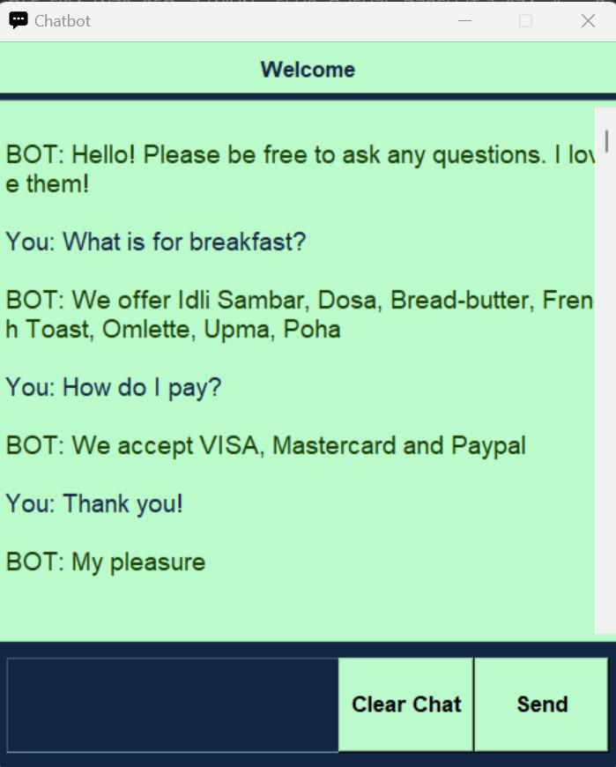
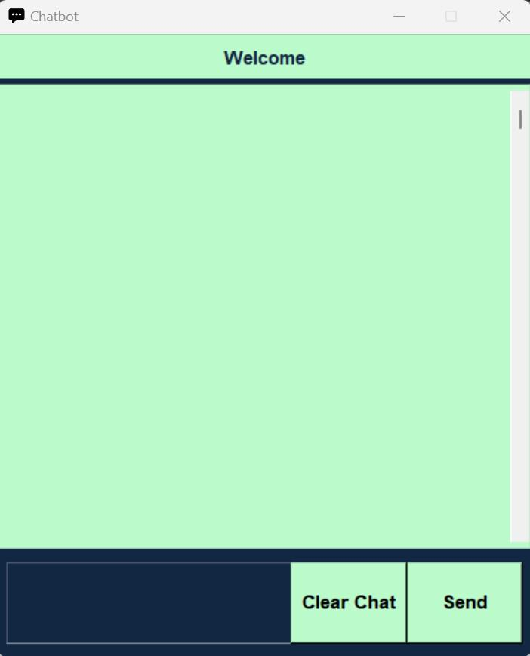
Fig 5: Starting Window Fig 6: A sample conversation

The output of the project can be found below for different queries based on their tags -
- Query 1
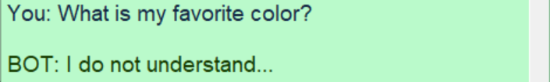h

- Query 2 (tag : greeting)
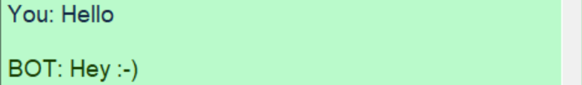

- Query 3 (tag : goodbye)
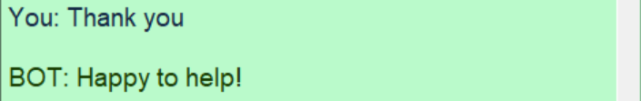

- Query 4 (tag : items)
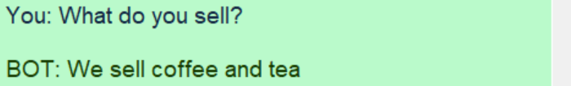

- Query 5 (tag : breakfast)
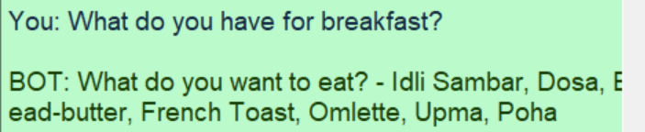

- Query 6 (tag : lunch)
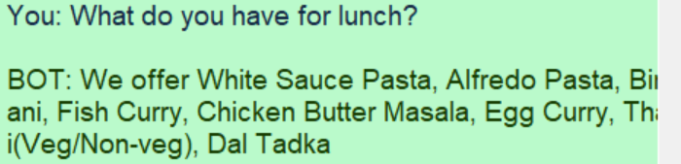

- Query 7 (tag : snacks)
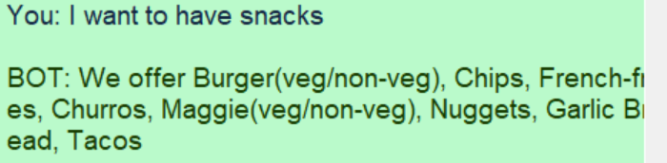

- Query 8 (tag : dinner)
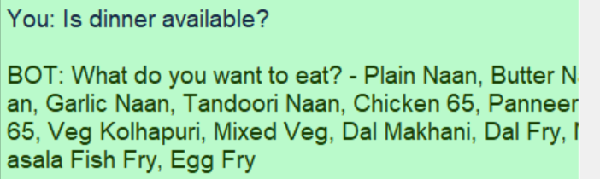

- Query 9 (tag : popular)
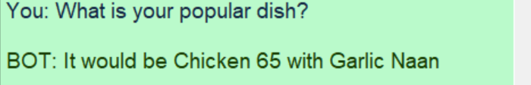

- Query 10 (tag : payments)
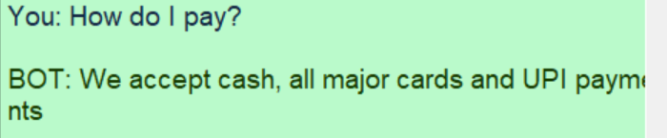

- Query 11 (tag : delivery)
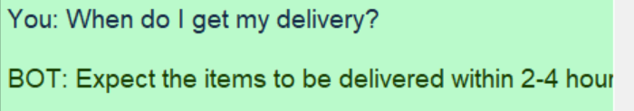

4.4 Quality Assurance
The quality assurance guidelines followed during the development of this project are as follows -
- Requirements gathering - All the customer requirements are analyzed and documented before developing the project.
- Testing plan - Regular testing and debugging are conducted while developing the bot to resolve the errors. The test cases are developed and documented in such a way that they cover all the functional and non-functional requirements.
- User guidelines - Clear documentation and instructions are documented for ease of use by the end users.
- Performance monitoring - The chatbot is monitored continuously and feedback will be collected from the customers to identify necessary areas of improvement.

Chapter 5

Standards Adopted

5.1 Design Standards
Here are some recommended practices followed for our project design:

- Identify the problem or need: Determine the problem or need that the project aims to address. This can involve researching current technologies, analyzing user needs, and identifying gaps in existing solutions.

- Define project goals and scope: Identify the specific goals and scope of the project, including the expected features, functionality, and limitations of the product. Create a project roadmap to outline the timeline and milestones for development.

- Choose the development methodology: Select a development methodology that fits the project's goals and constraints. Common methodologies include agile, waterfall, and iterative.

- Design the architecture: Define the software or hardware architecture, including the high-level design of the system, data flow diagrams, and component diagrams. Create a detailed design document that outlines the system's specifications.

- Develop the prototype: Develop a working prototype of the system to test its functionality and identify areas for improvement. This may involve creating a proof of concept or minimum viable product.

- Test the product: Conduct testing to verify the product's functionality and ensure that it meets the specified requirements. This can involve unit testing, integration testing, and system testing.

- Refine and finalize the product: Make refinements to the product based on user feedback and testing results. Conduct a final review and testing phase before finalizing the product.

- Deploy the product: Deploy the product to the target environment and provide documentation and training for end-users. Conduct ongoing maintenance and support to ensure the product's continued functionality and usability.

5.2 Coding Standards

Here are some commonly followed coding standards for project design:

- Consistent naming conventions: Use consistent naming conventions for variables, functions, classes, and other code elements.

- Indentation and formatting: Use consistent indentation and formatting to make the code more readable and maintainable.

- Commenting: Use comments to explain the purpose and functionality of code, especially for complex or non-obvious code.

- Error handling: Implement proper error handling and exception handling to ensure that the code is robust and resilient.

- Code reuse: Encourage code reuse by using modular and reusable code components, functions, and libraries.

- Security: Implement security measures such as input validation, authentication, and access control to prevent security vulnerabilities.

- Performance: Optimize the code for performance by using efficient algorithms, data structures, and techniques.

- Code reviews: Conduct regular code reviews to ensure that the code follows the coding standards and best practices and to identify any issues or areas for improvement.

5.3 Testing Standards

Here are some standards related to quality assurance and testing followed in our project:

- Standard for Software and System Test Documentation: This standard defines the requirements for test documentation, including test plan, test case specification, and test procedure specification.

- Standard for System and Software Verification and Validation: This standard outlines the requirements for verification and validation of software and systems, including planning, analysis, design, implementation, testing, and reporting.

- Standard for Systems and Software Engineering - Software Life Cycle Processes: This standard defines the software life cycle processes, including planning, assessment, design, development, testing, maintenance, and retirement.

- Standard Glossary of Software Engineering Terminology: This standard provides a common language and understanding of software engineering terminology.

- Standard for Software Quality Metrics Methodology: This standard provides guidelines for measuring software quality, including product, process, and project metrics.

- Standard for Software Reliability: This standard outlines the requirements for software reliability, including planning, modeling, testing, and analysis.

- Standard for Software Quality Assurance Processes: This standard defines the software quality assurance processes, including planning, evaluation, and reporting.

Chapter 6

Conclusion and Future Scope

6.1 Conclusion
We created our own database of standard customer queries and responses in the form of a JSON file. We then created a deep learning model using PyTorch which consists of a feed-forward neural network and then trained the model on the database we created. We then developed a chat application to implement the 'chatting' and integrated it with a Graphical User Interface created using Tkinter. Thus we were able to successfully develop and implement a chatbot.

6.2 Future Scope
Chatbots have vast potential applications in various industries, and their future scope seems to be very promising. Here are some areas where chatbots could have a significant impact:

- Personalization: Chatbots can learn from the user's behavior and preferences, providing personalized responses and recommendations that enhance the overall customer experience.

- Multilingual support: Chatbots can help break down language barriers by providing support in multiple languages, allowing businesses to cater to a broader audience.

- Customer service: Chatbots can provide quick and efficient customer service by resolving issues and answering questions 24/7. They can also reduce the workload of human customer service agents, enabling them to focus on more complex issues.

- Healthcare: Chatbots can help provide basic medical advice and support, offering patients access to information and immediate assistance.

- Education: Chatbots can be used as personalized tutors, assisting students in learning at their own pace and providing feedback and recommendations.

References

[1 ] T. Le-Tien, T. Nguyen-D-P and V. Huynh-Y, "Developing a Chatbot system using Deep Learning based for Universities consultancy," 2022 16th International Conference on Ubiquitous Information Management and Communication(IMCOM), Seoul, Korea, Republic of, 2022, pp. 1-7, doi: 10.1109/IMCOM53663.2022.9721735.

- A. M. Ramadhani and H. S. Goo, "Twitter sentiment analysis using deep learning methods," 2017 7th International Annual Engineering Seminar (InAES), Yogyakarta, Indonesia, 2017, pp. 1-4, doi: 10.1109/INAES.2017.8068556.

- S. Sawant, A. Vishwakarma, P. Sawant and P. Bhavathankar, "Analytical and Sentiment based text generative chatbot," 2021 12th International Conference on Computing Communication and Networking Technologies (ICCCNT), Kharagpur, India, 2021, pp. 1-7, doi: 10.1109/ICCCNT51525.2021.9580069.

- Y. -C. Guo and D. -X. Niu, "A Knowledge-Based Intelligent System for Power Customer Service Management," 2007 International Conference on Machine Learning and Cybernetics, Hong Kong, China, 2007, pp. 2925-2930, doi: 10.1109/ICMLC.2007.4370648.

- Min Li, Tao Li and Bin Hou, "A study on the relation among customer perceived value, customer satisfaction and customer value of service enterprises," 2011 International Conference on Computer Science and Service System (CSSS), Nanjing, 2011, pp. 140-143, doi: 10.1109/CSSS.2011.5974375.

- Q. Qiao, W. Wu and Y. Li, "Enhancing Consumer Usage of AI-Chatbots: The Role of Perceived Humanness, Social Presence, and Social Interactivity," 2022 8th International Conference on Information Management (ICIM), Cambridge, United Kingdom, 2022, pp. 97-103, doi: 10.1109/ICIM56520.2022.00025.

[7] B. Rawat, A. S. Bist, U. Rahardja, Q. Aini and Y. P. Ayu Sanjaya, "Recent Deep Learning Based NLP Techniques for Chatbot Development: An Exhaustive Survey," 2022 10th International Conference on Cyber and IT Service Management (CITSM), Yogyakarta, Indonesia, 2022, pp. 1-4, doi: 10.1109/CITSM56380.2022.9935858.

PROJECT TITLE : CHATBOT USING PYTORCH

Student Name - SUDIPA MANDAL
Student Roll number - 2028036

Abstract: This project aims at developing a customer service chatbot for a restaurant using Pytorch framework which provides a user-friendly interface for the customers. The chatbot is trained to recognize and respond to a wide range of customer inqueries including menu items, payment details and delivery inqueries. By using natural language processing (NLP) and deep learning techniques, the chatbot is able to provide precise response to each customer inquery, thus improving customer satisfaction.

Individual contribution and findings:
Contributions
As part of the team my contributions to the development of this project include -
- Creating Database - I worked upon creating a JSON file containing standard customer queries and responses, which acts as the database on which our PyTorch model gets trained on.
- Creating Training Data – I pre-processed the database and applied various techniques like tokenization, stemming, and bag of words to convert it into data suitable for training the deep learning model.
- Model development - I developed the deep learning model using PyTorch consisting of a feed-forward neural network and trained it on the data acquired from pre-processing the database.
Findings
After successful model development, I found out that the model is successfully created and trained on the data acquired after applying various pre-processing techniques like tokenization, stemming, and bag of words. I was able to successfully create my own custom database of standard customer queries and responses and use it to train my created model.

Individual contribution to project report preparation:
My contribution to this project report are as follows -
- Chapter 1 - Introductions
- Chapter 3 - 3.1 Project Planning, 3.3.2 System Architecture, Fig 3. Block Diagram
- Chapter 4 – 4.1 Methodology, Fig 3. Methodology
- Chapter 5 - 5.1 Design Standards, 5.2 Coding Standards, 5.3 Testing Standards
- Chapter 6 - 6.1 Conclusion, 6.2 Future Scope

Individual contribution for project presentation and demonstration:
- Introduction
- Basic Concepts - Natural Language Processing, Tokenization, Stemming
- System Architecture
- Methodology
- Future Scope

Full signature of the Supervisor: Full signature of student:
……………………………. …………………………….

PROJECT TITLE : CHATBOT USING PYTORCH

Student Name - RITWIKA DE
Student Roll number - 2028174

Abstract: This project aims at developing a customer service chatbot for a restaurant using Pytorch framework which provides a user-friendly interface for the customers. The chatbot is trained to recognize and respond to a wide range of customer inqueries including menu items, payment details and delivery inqueries. By using natural language processing (NLP) and deep learning techniques, the chatbot is able to provide precise response to each customer inquery, thus improving customer satisfaction.

Individual contribution and findings:
Contributions
As part of the team my contributions to the development of this project include -
- Tkinter app development - I worked upon developing the chatbot environment and various widgets for the app such as: text widget, scrollbar, enter button and the clear chat button
- Model integration - I integrated the model with the chatbot app by calling the necessary functions and importing the required modules for processing the user inputs and providing a relevant output in the user interface i.e the Tkinter window.
- Testing and debugging - I tested the working of the chatbot by asking appropriate questions a customer would ask to a customer service bot. I also identified errors in the bot and modified the code accordingly to remove them.

Findings
After successful testing and debugging of the chatbot, I found out that the chatbot is able to deliver relevant responses to customer queries. The integration of the chatbot model was successful with the Tkinter app. I also learnt alot about the Tkinter package while developing the app for the chatbot. After testing the bot, the suitable errors were removed profoundly.

Individual contribution to project report preparation:
My contribution to this project report are as follows -
- Abstract
- Chapter 2 - Basic Concepts
- Chapter 3 - 3.2 Project Analysis, 3.3 System Design
- Chapter 4 - 4.2 Testing, 4.3 Result Analysis, 4.4 Quality Assurance
- References

Individual contribution for project presentation and demonstration:
- Basic Concepts - Deep Learning techniques, Pytorch Framework, Tkinter
- Chatbot Functions
- Test Cases
- Result Analysis
- Conclusion

Full signature of the Supervisor: Full signature of student:
……………………………. …………………………….

TURNITIN PLAGIARISM REPORT

